

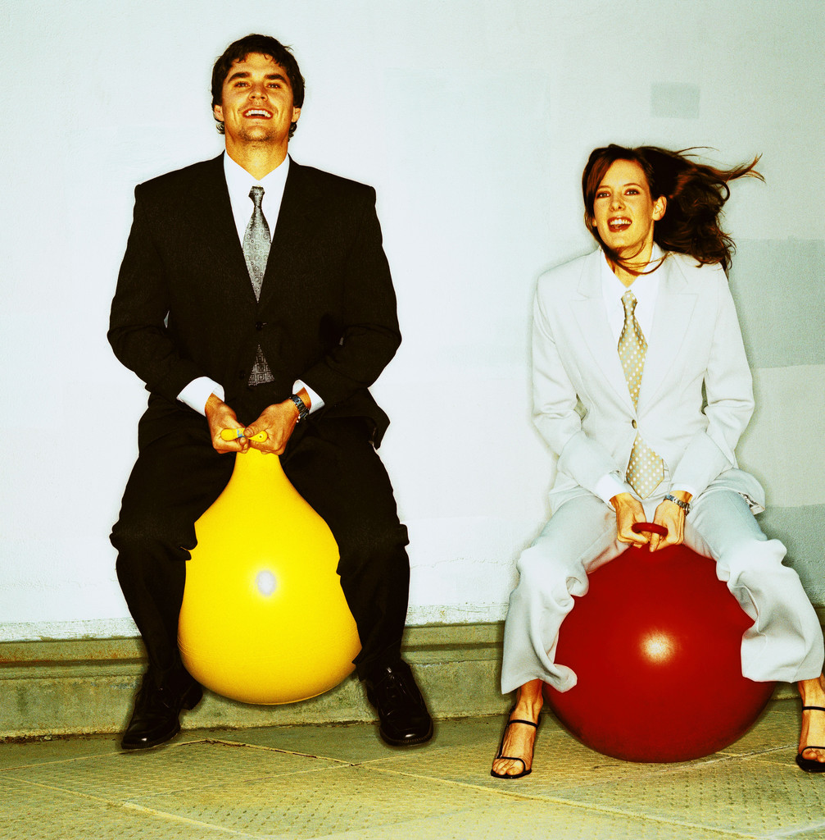

## Parks, Recreation and Tourism Management

## Transfer Information

## Sessions

## 

**Students interested in: Sport Management Tourism and Commercial Recreation Program Management Natural Resources Professional Golf Management**

**Join us to learn more about the transfer requirements for the PRTM program and about the job opportunities that are available in the field.**

#### WHERE: 4024 Biltmore Hall: Hines Room WHEN: Tuesday, September 10th @ 3:30pm

Friday, October 18th @ 1:00pm

Tuesday, November 5th  @ 1:00pm

For more information go to: http://cnr.ncsu.edu/event